Dale to Lundy and back by Norfolk Oyster.
9/10 July 2015.
Surrounded by dolphins; approx 80 nm, including overnight on Lundy with Antony Gormley’s statue.

Extending our travel around the coast, we intended to join up the Welsh and Cornwall coasts by a sail from Dale (Milford Haven) to Lundy and on to Clovelly and back. Time was limited as we had George and Marilou visiting over 4-7 July and Antony was rowing at Henley on 11 July. The Greeks seemed bound to exit the Euro, Murray had just booked a semi-final place against Federer and the Australians cricketers were about to trounce England in Cardiff.
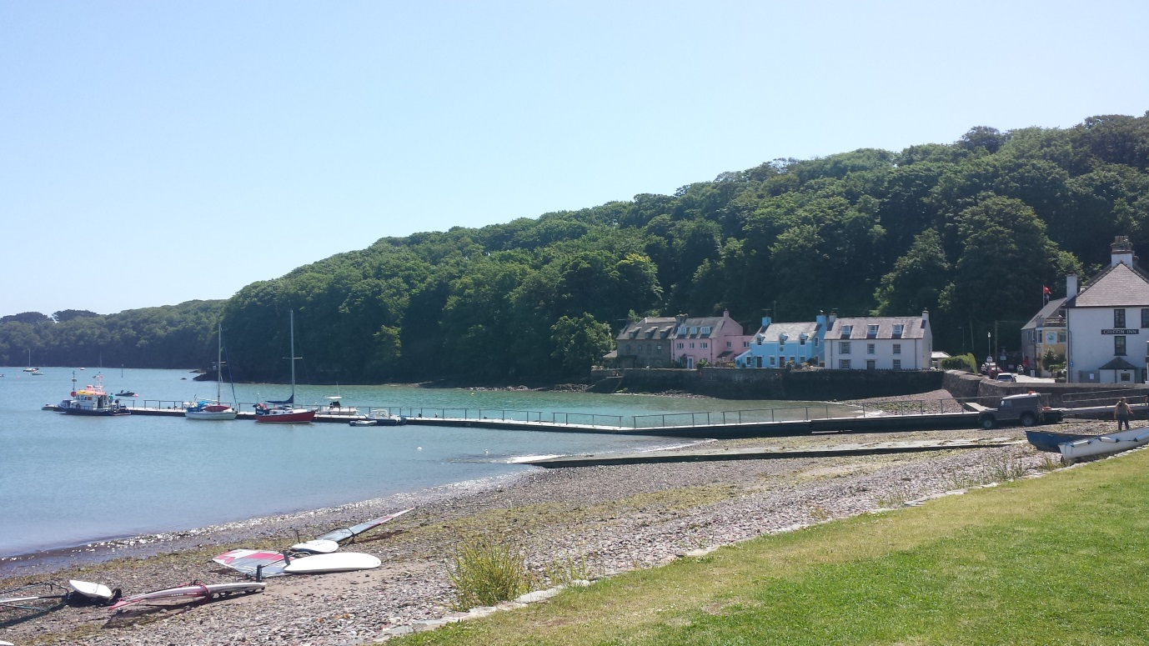
Floating Pontoon at Dale beside the Griffin Inn and Dale Yacht Club
The weather forecast looked OK until the last few days before the trip, when the BBC weather alerted us to rough weather on Wednesday 8 July with 40mph winds. Windguru showed strong 25-30 knots, Windfinder similar. Penny stayed an extra day with family. Antony and I set up camp in Dale on the Tuesday night. Weather forecasts continued to look too strong for Wednesday, confirmed by Milford Haven Coastguard (NW 5-7 Rough). Antony and I decided to have a sail; Penny said the weather would improve on Thursday so planned to join us on Wednesday evening. We reefed and sailed out of Milford Haven, found some of the buoyage marks we would need for the trip, but the swell was big, we got drenched, and had to spill most of the wind. We decided on a trip up the Cleddau on flatter water, running at 6-7 knots up towards Neyland. We tacked in to the Pembrokeshire Yacht Club (No quay, no moorings, looked closed) and turned upstream to Hakin Jetty beside The Kings Arms Inn. On arrival discovered it was not open until 3pm. The Fish Plaice told us we could walk over the closed lock gates - or try the Heart of Oak, which was open. Sandy the Carpet introduced himself and we soon found the Galley Café open for lunch. Brilliant ….£9.50 for 1 x Full English Breakfast and 1 x Ham Egg & Chips + coffee /tea. Good camaraderie in the Galley café which appeared well advised by a barrister in attendance. Back in time to avoid ‘Mopsy being suspended from the Quay (7 metre tidal range).
Penny joined us on Wednesday evening and discovered I had left the precious Garmin GPS unprotected from the sea and it was clearly not feeling well. Mea Culpa. We checked the weather yet again and elected to go on Thursday morning by when it should have eased to NW 3-4 Moderate. We would only have one night on Lundy and not have the time to get to Clovelly.
We set off from the pontoon at Dale at 0820 hrs in still calm weather and continued to motor for some time. The weather seemed placid and it was surprising how quickly the sea had flattened off from the day before. We registered with Milford Coastguard and were then contacted by the Protection Officers for the firing ranges to keep clear of the West Cardinal mark at Turbot Bank before heading south to Lundy. We motored along for a couple of hours when Antony pointed to a huge splash beside the boat. We were surrounded by 10-12 dolphins running behind us, beside us - and in front of our bow wave.
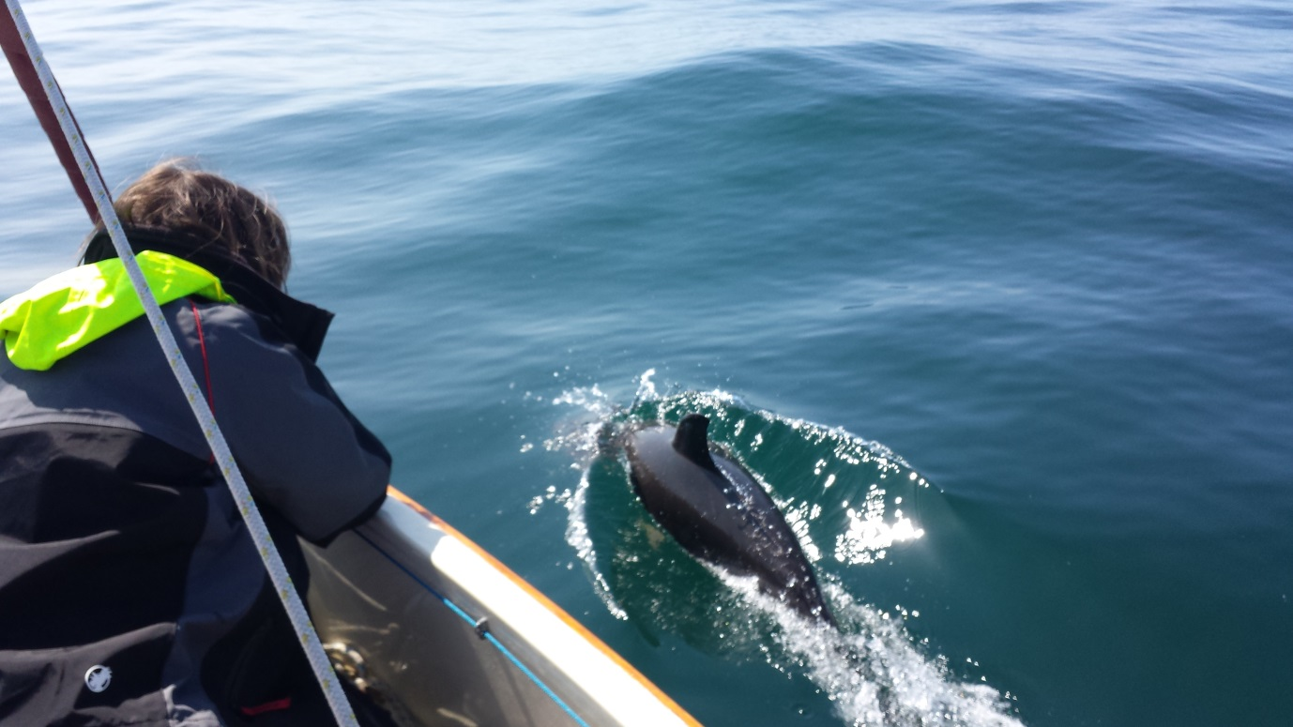
They must have stayed with us for 20-25 mins returning enough times for Penny in the bow to identify Raggeldy Fin (scarred dorsal fin) White Spot (on the hind left quarter) and Propeller Back (scarred by propellers ?). At that time we then encountered another school of Dolphins, some with babies and we were now bemused by the number of them rising, breaking and diving beside and in front of us. We had never seen so many at such close quarters that Penny was almost able to touch them - and with such sweet baby dolphins. Eventually they left us. The wind picked up and we sailed the next 5 hours on towards Lundy, Antony noticing the thin outline of Lundy first, with a solitary cloud hanging over it. We amused ourselves with lunch (Antony was Senior Catering Officer and has a spare career if needed), keeping a check on our fixes with the DSC Radio co-ordinates, and quizzes, spotting Shearwaters, Puffins and Gannets.
To avoid the overfalls developing after low tide 1832 hrs on Lundy at the northern end, we motor sailed the last hour to the northern tip of Lundy under Trinity Lighthouse, then into calm water down the eastern side with colonies of seals on the rocks below an attractive coastline. We called Milford Coastguard to confirm safe arrival and moored at 1915 hrs near the landing jetty. You have to be self reliant arriving at Lundy; there is one visitors mooring bouy which you may not reserve; no water taxi or enough other boats…..
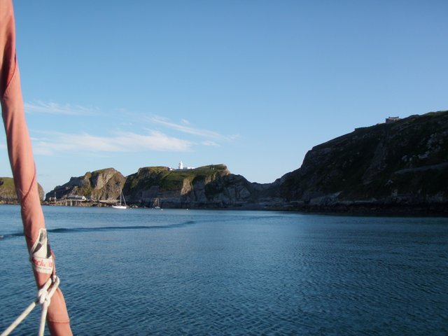
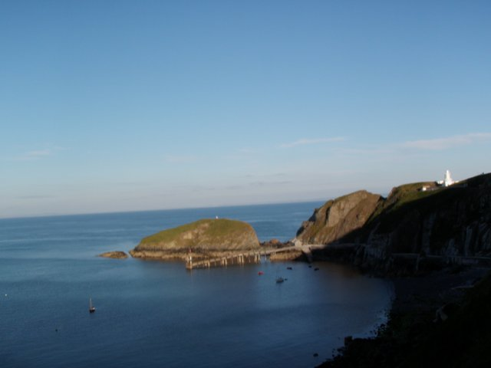
Arriving at the South East end of Lundy and Miss Mopsy at ease on a mooring
…to rely on cadging a lift. So we had brought extra anchors in case we could not moor, and Antony’s own little rubber boat which served us well. We pitched tents and were just in time for supper at the only pub, and then made time to visit the church (which includes a tray of rock samples common to Lundy) and make our way to Antony Gormley’s sculpture of a statue on the South West headland of the island, whose feet appear to be pointing south towards Hartland Point and whose body could otherwise be viewing the Atlantic. There is a clever ambiguity about it’s posture.
Upsticks in the morning - tents and all, and we were leaving the mooring by 0735 hrs, this time heading around the southern part of Lundy, so we completed a lap of the island and set course for Dale with a decent 3-4 southerly wind and a following wave pattern giving us 5-6 knots over the ground, sailing all the way home. The Jetboil earned its keep with coffee and we rolled along for a few hours checking our position every hour or so. Penny found her tablet would capture some information. Mark Cavendish had won a stage in the Tour de France. We got to the 50m depth line and there were Dolphins coming across us. We called out and they turned to run with us – there must have been 20-30 of them but we could not identify any we had seen the day before, but these new Dolphins also had special markings…Two Star etc.
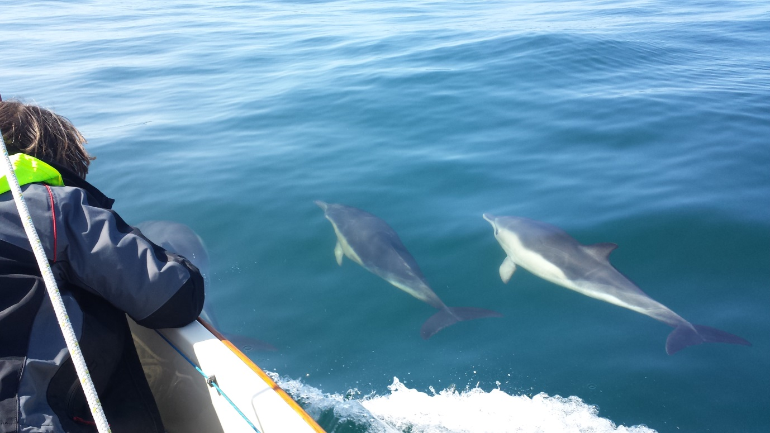

We wondered if the 50m depth line (after which it shallowed to 25-35m) threw up food supplies for the Dolphins, as it was about the same 50m depth line where we first encountered the Dolphins on the way out.
Closing on the Welsh coast we checked again with Milford Coastguard about the firing ranges and were asked to keep south of St Governs Head south cardinal bouy which we did, but still attracted a visit by the Protection Vessel, who pointed out a moving bouy – part of the Firing range practice.
We were back into Milford Sound and Dale harbour around 1830 hrs. Antony had time to get home before Henley the next day. Murray had just gone down to Federer. England had set Australia 412 to win. Greece were still in the Euro.
It had threatened to rain on us for the last hour or so but never did so. Penny confirmed safe arrival with the Coastguard. Miss Mopsy was back on her trailer within 30 mins and another c 80 nm to her credit.
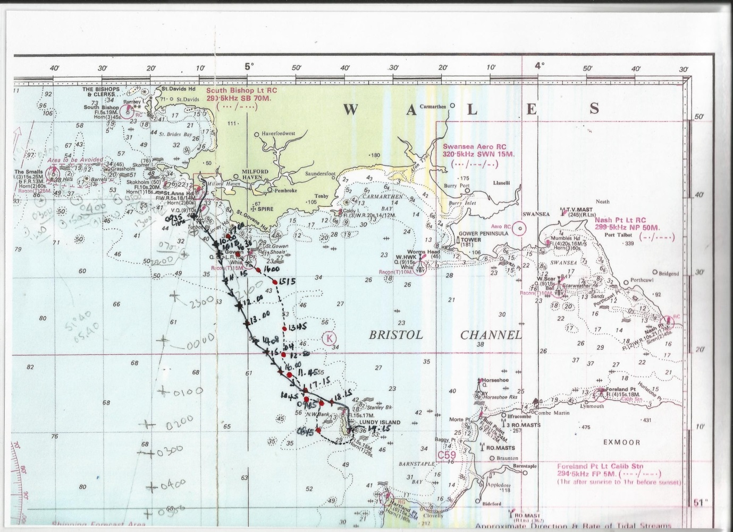
Route with Fixings to and from Lundy….solid line out, dotted line return.
GNR 15.7.2015

